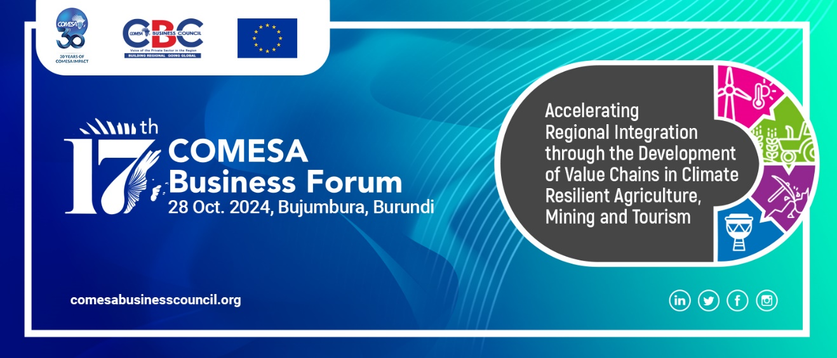

STATEMENT

By

Her Excellency, Chileshe Mpundu Kapwepwe

Secretary General

Common Market for Eastern and Southern Africa (COMESA)

To

17th COMESA Business Forum

On

28th October 2023

BUJUMBURA, BURUNDI

SALUTATIONS:

- H.E Gervais NDIRAKOBUCA, Prime Minister of Burundi (Official Opening of the Business Forum);
- Hon. Marie Chantal Nijimbere, Minister of Trade, Transport, Industry, and Tourism, Burundi.
- Hon. Chipoka Mulenga - Minister of Commerce, Trade and Industry, Zambia,
- Mr. James Chimwaza, President, COMESA Business Council (CBC),
- CBC Board of Directors,
- Representative of the European Union,
- Honourable Ministers from COMESA Member States,
- Permanent Secretaries.
- Representatives of Government Institutions,
- CEOs of Business Associations,
- Captains of industry,
- Members of CBC,
- Members of the Press,
- Distinguished Guests,
- Ladies and Gentlemen.

All protocols observed.

I Greet You All, Good morning.

It gives me great pleasure to be with you during this annual event for the COMESA Business Council and the business community at large. We are gathered here for the 17th High Level COMESA Business Forum, building upon the success of the 16th Forum held last year in Lusaka, Zambia.

I wish to take this opportunity to welcome everyone to the Forum, with a very special and warm welcome to those coming from outside Burundi. I also wish to recognise the presence of H.E Gervais Ndirakobuca, Prime Minister of the Republic of Burundi and Hon. Marie Chantal Nijimbere, the Minister of Trade, Transport, Industry, and Tourism, also of the Republic of Burundi, who are our host. Similarly, I wish to recognise the presence of Hon. Chipoka Mulenga, the Minister of Commerce, Trade and Industry from the Republic of Zambia. I would also like to welcome the new leadership of CBC led by Mr. James Chimwaza, President, COMESA Business Council (CBC) and thank the past CBC leadership for a good working relationship, especially in promoting private sector growth and development in the COMESA region, while upholding the principles of good governance.

The theme for the 17th High Level COMESA Business Forum is “Accelerating Regional Integration through the Development of Regional Value Chains in Climate Resilient Agriculture, Mining and Tourism”, which speaks to some of the key issues that are expected to transform the COMESA Member States into competitive and sustainable growing economies in trade and investment. We are privileged on this occasion to have a high-level Round Table, where stakeholders will have opportunity to discuss the support towards creating a competitive business environment in the COMESA region, focusing on regional value chains in climate resilient Agriculture, Mining, and Tourism.

Ladies and Gentlemen,

While facing global economic challenges, COMESA has shown resilience and adaptability in its trade performance. Although there was a slight decrease in overall trade figures, the region has maintained stability in key areas and demonstrated potential for growth.

Notably, intra-COMESA export trade held steady at US$14 billion in both 2022 and 2023, highlighting the strength of regional economic ties. This consistency in intra-regional exports provides a solid foundation for future growth and deeper economic integration.

The current intra-COMESA trade level of 6% presents a significant opportunity for expansion. By focusing on addressing trade barriers and enhancing regional cooperation, COMESA has substantial room to increase intra-regional trade, potentially matching or exceeding the performance of other Regional Economic Communities.

Looking ahead, COMESA is well-positioned to leverage its collective strengths and address the factors affecting global and intra-regional trade. By consolidating our efforts, we can develop more sustainable businesses and robust economies that are fully equipped to compete and capitalize on regional market opportunities. This period of adjustment offers COMESA the chance to reassess strategies, innovate, and emerge stronger in the global economic landscape.

Ladies and Gentlemen,

To increase COMESA’s trade globally and within the region, there is a need for concerted efforts by all Institutions of COMESA. As the COMESA Secretariat, we shall continue to leverage the strength of the existing COMESA institutions such as CBC to increase COMESA trade through private sector growth and development. I am informed that CBC is expected to develop a regional Private Sector Development Strategy to guide the growth and development of the Private Sector in the COMESA region.

For instance, COMESA Secretariat is implementing the African Union (AU)’s Pharmaceutical Manufacturing Plan for Africa (PMPA) and the African Medicines Regulatory Harmonization (AMRH) in the context of the COMESA region. The overall objective of the initiative is to strengthen the region’s pharmaceutical institutions, regulatory bodies, quality control and management systems for the development of the pharmaceutical industry. This has come at a time when Member States are recovering from the effects of the COVID-19 pandemic. The key components of this initiative include institutionalization and domestication of the pharmaceutical manufacturing plan for Africa and the African Medicines Regulatory Harmonization program; strengthening of the region’s medicines and pharmaceutical regulatory bodies/institutions in the region; building the capacity of key stakeholders and supporting trans-regional research and development programs. The project is progressing well, and we hope to achieve the objectives of this initiative.

In addition to the above, the COMESA Secretariat is working closely with CBC to promote the free movement of businesspersons in the COMESA region through gradual relaxation and eventual elimination of visa requirements within the COMESA region. To understand the status, a joint study was undertaken between the COMESA Secretariat and CBC this year. The findings pointed out the fact that most of the Member States have made tremendous progress in visa relaxation. They have either allowed visas upon arrival or visa free entry for up to 90 days and removed visa restrictions. Some Member States have achieved the highest level of implementation of the visa protocol relating to the gradual relaxation and elimination of visa requirements within COMESA (1984). The study recommended that the Member States should go beyond entry requirements by looking at rights of establishment and residents including work permit regimes.
I wish to commend CBC for their continuous effort to implement the Digital Financial inclusion project in COMESA. The goal of the project is to support the design, development, and deployment of an Integrated digital financial services infrastructure that is low-cost, interoperable, near real time and fraud resistant that serves Micro Small and Medium sized Enterprises (MSMEs) and the customers they transact with at the bottom of the financial pyramid.
Ladies and Gentlemen,

The COMESA region is endowed with an abundance of diverse natural resources. The region has the potential of attracting many tourists who can significantly contribute to the regional GDP and create employment for the locals. Each of the 21 Member States of COMESA has distinct magnificent tourist highpoints, beautiful diverse cultures, breath taking heritage sites and a number even hosting some of the seven wonders of the world. Once boosted and supported, tourism in the COMESA region has the potential to contribute to poverty reduction, become a source of foreign currency generation, and promote Foreign Direct Investment (FDI). In COMESA, tourism was heavily affected by the pandemic because most of the inbound arrivals were from countries which were most hit by COVID-19. This is an opportunity for the region to re-strategize on how to continue accelerating its recovery

As I indicated earlier, COMESA Member States are endowed with an abundance of natural resources including different mineral resources which can be processed as inputs in the manufacturing sector or exported in refined form, thereby earning more revenue in the international market. However, almost all of COMESA`s mineral wealth is currently exported as ores, concentrates, alloys, or metals with little value addition. This has led to the export of labour to other regions. It is important for Member States to discuss and come up with measures to promote value addition for minerals to improve earnings. COMESA has regional local content policy guidelines that can help Member States in this sector

Ladies and Gentlemen,

As I conclude, the importance of the critical that private sector plays in a nation’s socio-economic development cannot be overemphasised. COMESA, through the COMESA Business Council and our other institutions, will continue to actively engage and dialogue with the private sector in platforms such as this one. Such engagements afford an opportunity for valuable insights and feedback from the private sector, which is critical for enhancement of policy formulation and ultimate support for sustainable economic development.

I end by wishing all participants fruitful deliberations, I thank you all for your attention.

